Names: Serafino Pampena,

Yijia Jiang

Christopher Velasquez-Chavez

Dara Cinema is looking to expand its customer base, particularly among younger audiences. To achieve this, they plan to develop a **reservation application** that enhances the movie-going experience with a VIP touch.

The app will allow clients to:

* **Reserve seats** in advance.
* **Apply discounts** to their bookings.
* **Order food and drinks** directly from the app.
* **Receive notifications** about schedule changes, promotions, or special events.

Additionally, the cinema owner requires an **admin dashboard** to manage movie listings, track reservations, and monitor customer engagement.

This project will help Dara Cinema modernize its services, attract younger audiences, and provide a seamless, high-end movie experience.

Design patterns chosen:

* Builder to create each movie made.
* State for the user to select a seat when ordering.
* Factory to create the users.
* Singleton for the database connection.
* Facade to notify the user for any changes in the movie.
* Decorator for the tickets to add extra benefits like popcorn.
* Command also for the seat reservation.
* Strategy for the final pricing like student discount, VIP package or the regular price.
* Adapter design pattern for users like VIP

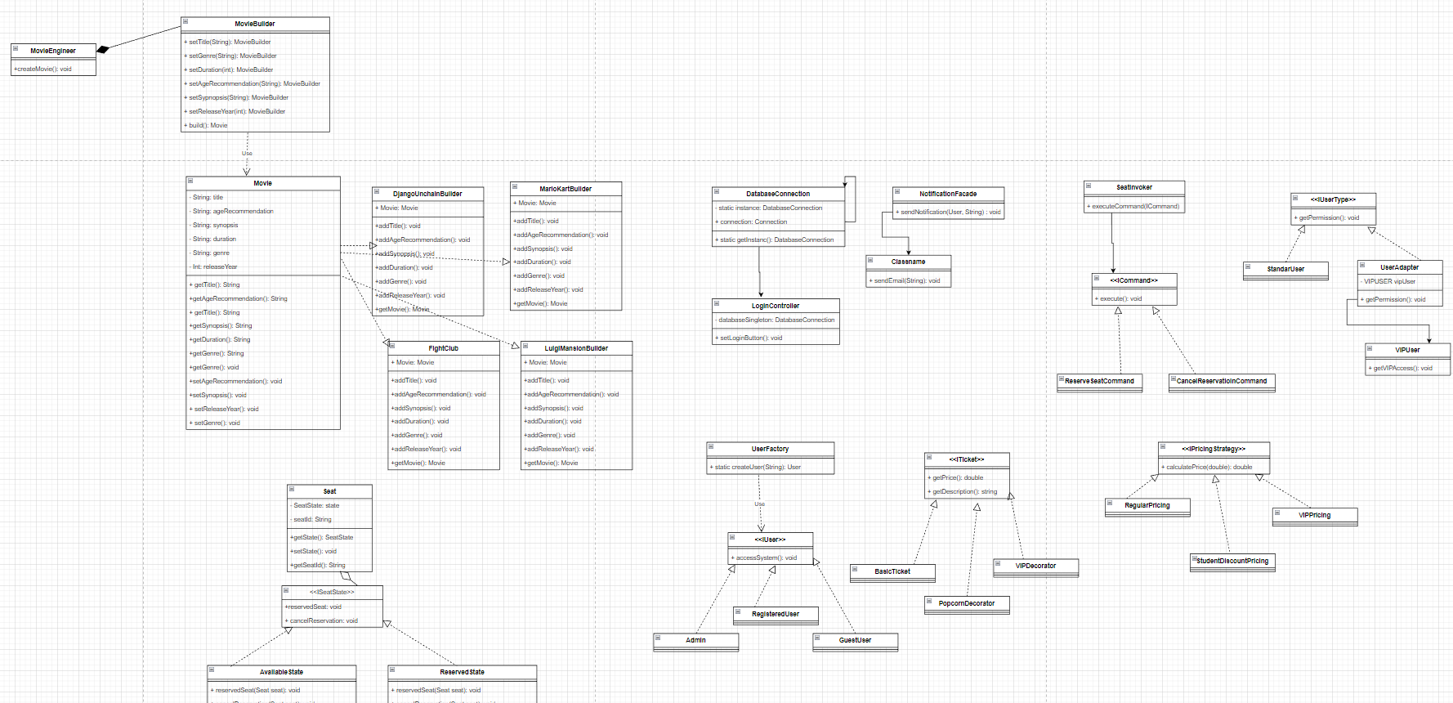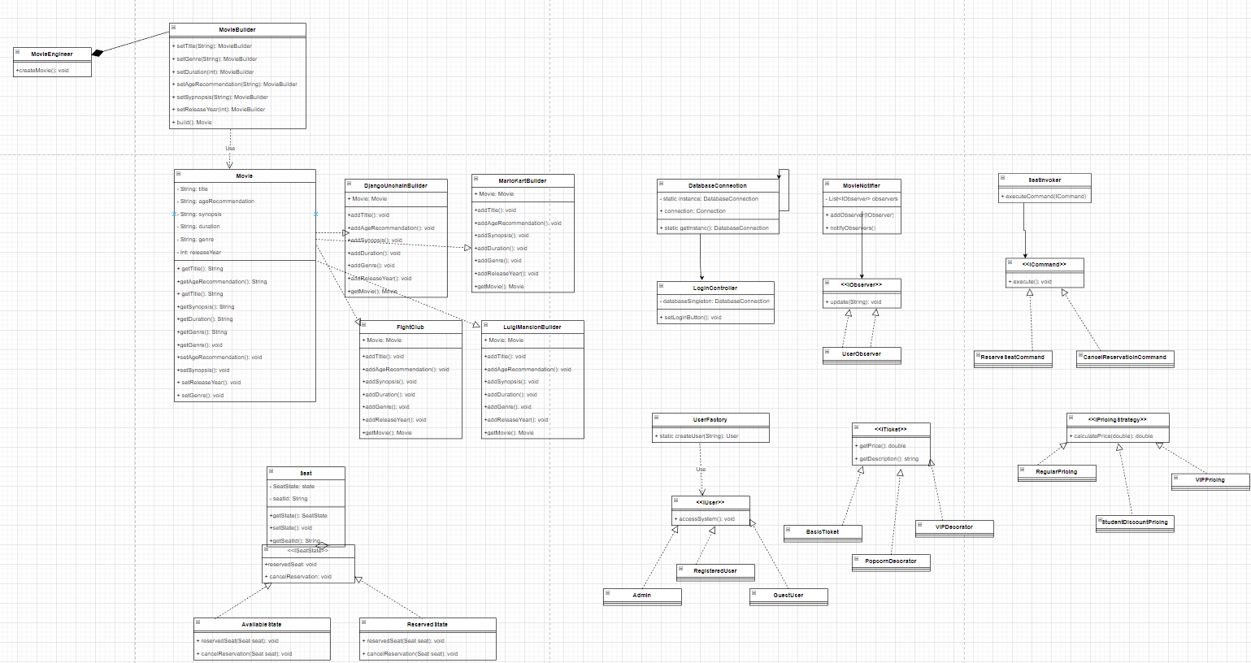

Use case Diagram:

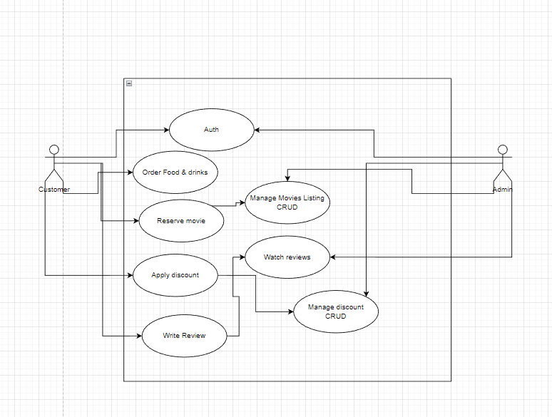

To do list:

Switch the database to another one. Like Firestore.

Create Admin user.

Admin must be able to read user reviews.

Admin is also able to do CRUD for user’s discounts

Admin CRUD operation for the movies

Alter the payment system to allow the discounts.

Refrain to have visitor reservation.

Add the option for the user to put extra benefits like drinks, popcorn, etc.

Add command so the user can cancel their reservation.

Add review for the user and do CRUD.